2.12 Software Defined Radio Team

**This project is intended to function as an educational tool for amateur radio enthusiasts and students. As a result, cost and clarity are important elements in this project. At the completion of the project, clear schematics, code, and parts list will be posted online and be available for reference.**

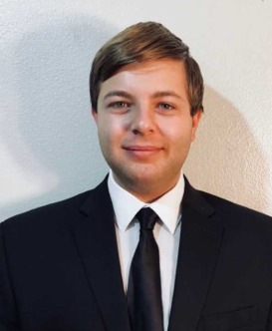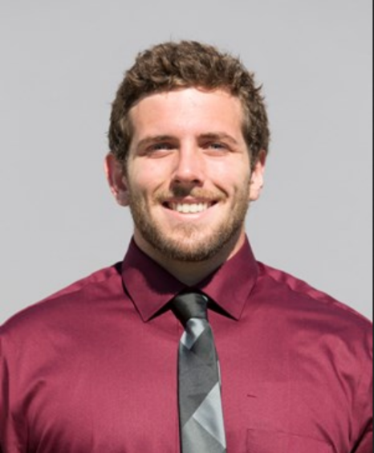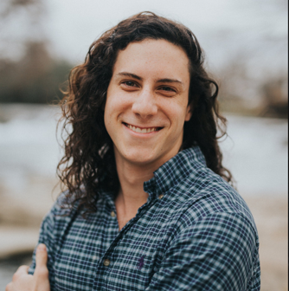

Figure 1: James Bell Samuel Hussey Zachary Schneiderman

|  |  |
| --- | --- |
| Name | Responsibility |
| James: | *Research of overall system and design* |
| James: | *Modulation Research* |
| James: | *Digital signal processing code* |
| Zach: | *RF Amplifier* |
| Zach: | *Enclosure and User Interface* |
| Zach: | *Clock Generator and Mixer Circuit* |
| Samuel: | *Filter Design and Test* |
| Samuel: | *Switching Relays* |
| Samuel: | *RF Splitter and Combiner* |